Explain the following questions in two simple sentences

1. What is the use of the git add command?

**Ans :-** The git add command stages changes in your files so they can be included in the next commit. It prepares your work to be saved in the repository history.

1. Write the command to create a branch “feature-group”.

**Ans :-** git branch feature-group

1. What is a pull request? Write the steps involved in creating a pull request.

**Ans :-** A pull request is a way to ask for your code changes to be reviewed and merged into another branch, usually main.  
Steps:

* Push your branch to GitHub.
* Go to the repository on GitHub.
* Click on “Compare & pull request.”
* Add a title, description, and click “Create pull request.”

1. How do you add collaborators?

**Ans :-** Go to your repository on GitHub, click on "Settings" → "Collaborators and teams".

Search for the GitHub username and click “Add” to give them access.

1. What is the command used to commit our changes in github repo?

**Ans :-** git commit -m "Your commit message"

1. Create a github account and repository to save all your assignment tasks. Example repository name: rg-assignments
2. Create a branch called feature-java(you can use it later to push all your java related tasks to this branch)
3. Install IntelliJ IDE. Create a simple java project displaying “Hello World!!”and share the screenshot.

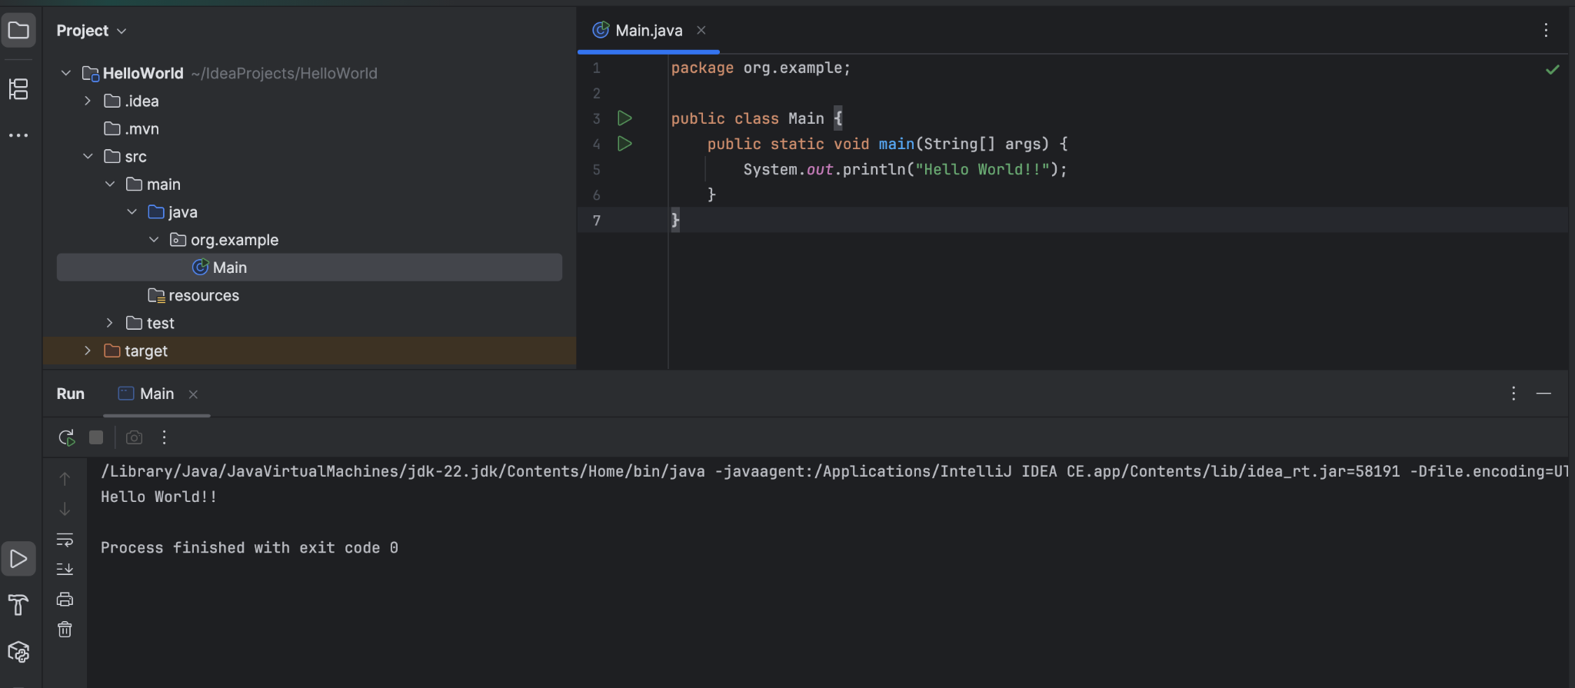

1. In IntelliJ IDE, explore the shortcut keys for the following
   1. To run the project
   2. To select a line
   3. To comment/uncomment a line
   4. To delete a line